**1. INTRODUCTION**

**1.1 Project overview**

This Project view provides an overview of the skill and job recommended for individuals interested in a career in any fields. It discusses the important role that any field plays in businesses and the various skills that are necessary for success in this field. It also outlines the different job opportunities available in any field and the different types of companies that employ any field professionals.

**1.2 Purpose**

Having lots of skills but wondering which job will best suit for you? Don’t need to worry! we have come up with a skill recommender solution through which the fresher or the skilled person can login and find the jobs by using search option or they can directly interact with the chatbot and get their dream job.

To develop an end to end web application capable of displaying the current job openings based on the skillset of the users.The users and their information are stored in the Database. An alert is sent when there is an opening based on the user skillset. User will interact with the chatbot and can get the recommendations based on his skills.We can use job search API to get the current job openings in the market which will fetch the data directly from the webpage.

**2. LITERATURE SURVEY**

# LITRATURE SURVEY 1:

**NAME OF THE PAPER :** Job Recommendation based on Job Seeker Skills.

**NAME OF THE AUTHOR :**Jorge Valverde-Rebaza ,Ricardo Puma ,Paul Bustios,Nathalia C. Silva.

**JOURNAL PUBLISHED :** First Workshop on Narrative Extraction From Text co-located with 40th European Conference on Information Retrieval.

**PUBLISHED MONTH :** March

**PUBLISHED YEAR :**2018

## OBJECTIVE OF THE PROJECT:

* In this ,when a candidate submits his/ her profile at a job seeker engine.
* Their job recommendations are mostly suggested taking their academic qualification and work experience into considerations.

# LITRATURE SURVEY 2:

**NAME OF THE PAPER :** A survey of job recommender systems.

**NAME OF THE AUTHOR :** Shaha Alotaibi.

**JOURNAL PUBLISHED :** International Journal of Physical Sciences

## PUBLISHED MONTH : July

**PUBLISHED YEAR :** 2012

## OBJECTIVE OF THE PROJECT:

* The recommender system technology aims to help users in finding items that match their personnel interests, it has a successful usage in e-commerce applications to deal with problems related to information overload efficiently.
* This article will present a survey of e-recruiting process and existing recommendation approaches for building personalized recommender systems for candidate.

**TECHNOLOGY USED :** Boolean search methods

# LITRATURE SURVEY 3:

**NAME OF THE PAPER** : A Research of Job Recommendation System Based on Collaborative Filtering.

**NAME OF THE AUTHOR** : Cheng Yang, Yingya Zhang, Zhixiang Niu.

**JOURNAL PUBLISHED :** 2014 Seventh International Symposium on Computational Intelligence and Design.

**PUBLISHED MONTH :** December

**PUBLISHED YEAR** 2014

## OBJECTIVE OF THE PROJECT :

* It analyze the candidate’s resume and the companies’ recruitment guidelines.
* To compare and come to a better conclusion upon finding the best suited candidates for the job.

**TECHNOLOGY USED :** Collaborative filtering algorithm.

# LITRATURE SURVEY 4:

**NAME OF THE PAPER** : Job Recommendation through Progression of Job Selection.

**NAME OF THE AUTHOR** : Amber Nigam, Aakash Roy, Hartaran Singh, Harsimran Waila.

**JOURNAL PUBLISHED** : 2019 IEEE 6th International Conference on Cloud Computing and Intelligence Systems(CCIS).

**PUBLISHED MONTH** : April

**PUBLISHED YEAR** 2020

## OBJECTIVE OF THE PROJECT :

* It uses the candidates' job preference over time to incorporate the dynamics associated with highly volatile job market.
* The best results have been achieved through Bidirectional Long Short Term Memory Networks (Bi-LSTM) with Attention for recommending jobs through machine learning.

**TECHNOLOGY USED :**Filter-based technique.

# LITARTURE SURVEY 5:

**NAME OF THE PAPER :** Job Recommender Systems.

**NAME OF THE AUTHOR :** Juhi Dhameliya, Nikita Desai.

**JOURNAL PUBLISHED :** 2019 Innovations in Power and Advanced Computing Technologies(i- PACT).

**PUBLISHED MONTH :** March

**PUBLISHED YEAR** 2019

## OBJECTIVE OF THE PROJECT :

* It is used for building the personalized recommendation systems for job seekers as well as recruiters.
* The main issue of these portals is their inability to understand the complexity of matching between candidates' desires and organizations' requirements.

**TECHNOLOGY USED :** Boolean search methods - Word matching algorithms.

**2.1 Problem Statement Definition**

Job skills recommended application

# Problem Statement:

**Goal:**

***A job search has to be very intuitive for the students so that they can find job suiting their skills, position, industry, role and location by company name.***

* The job Skills recommended application is an example of a search where documents are bulky because of the content in candidate resumes.
* The search provide over the candidate database is required to have huge set of fields to search.

# Problem:

The current problem recruitment is done manually, most available jobs in Nigeria can only be applied at the agency can be done for which job seekers have to go to the agency check the available jobs at the agency.

# Solution:

“The purpose of job oriented application to help both the job seekers and

recruiters find the right organization or the employers.”

**3. IDEATION & PROPOSED SOLUTION**

**3.1 Empathy Map Canvas**

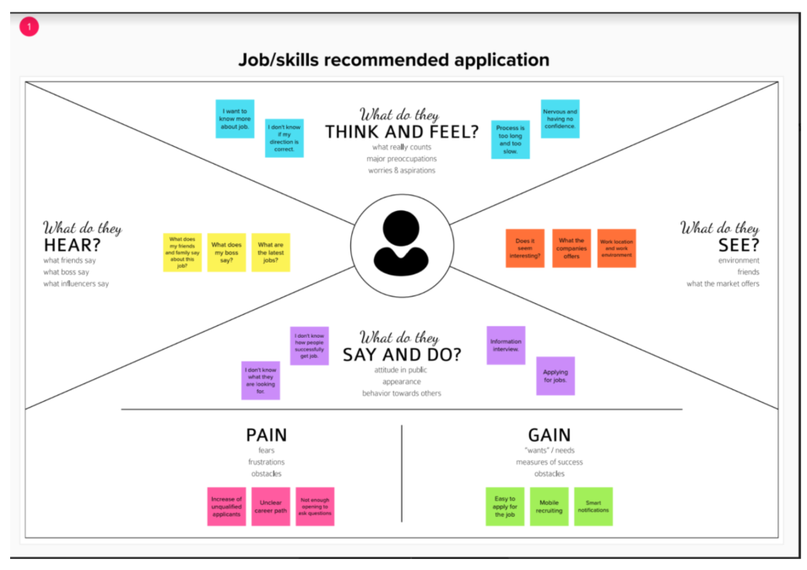

**3.2 Ideation and Brainstroming:**

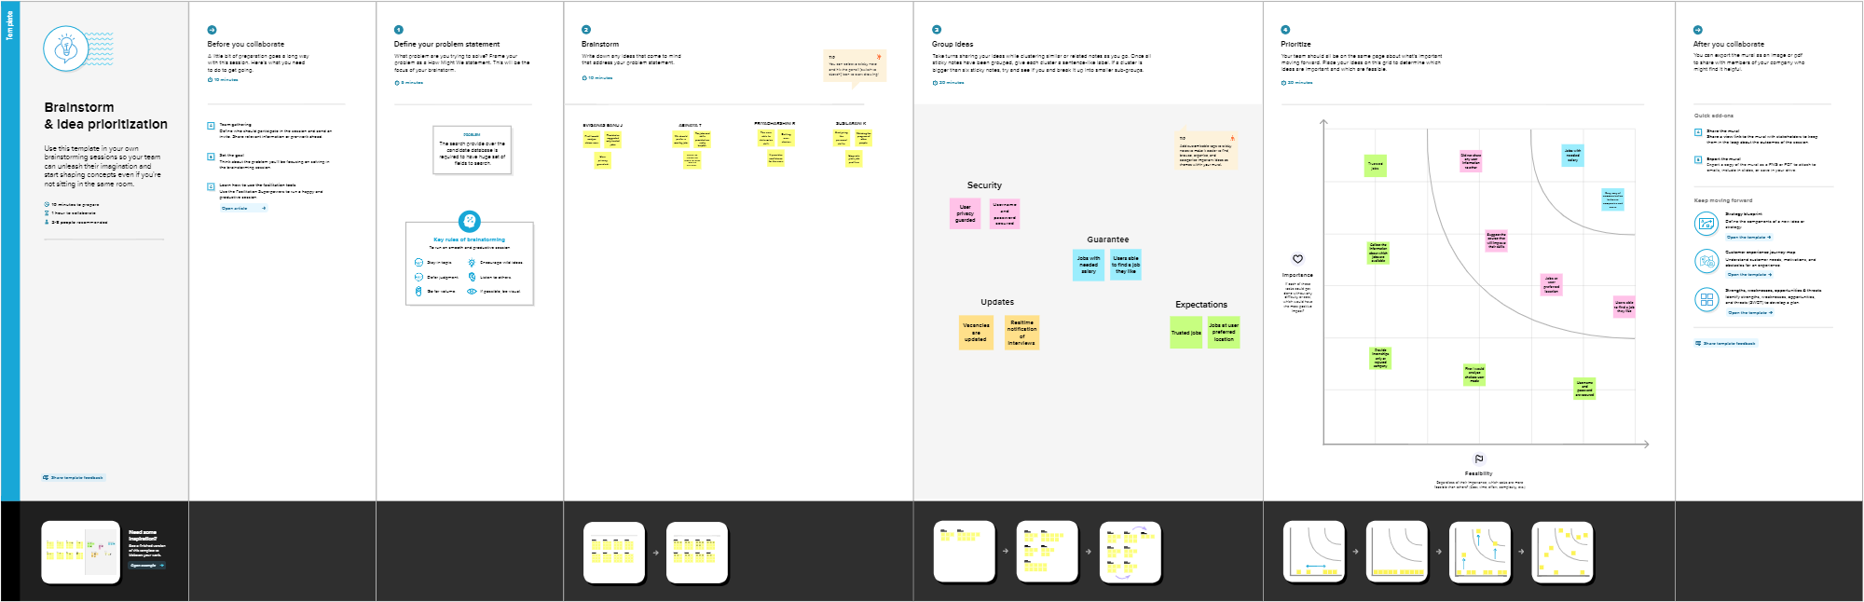

**3.3 Proposed Solution**

**Proposed Solution :**

|  |  |  |
| --- | --- | --- |
| **S. No.** | **Parameter** | **Description** |
| 1. | Problem Statement (Problem to be solved) | Having lots of skills but wondering which job will best suit you? Don’t need to worry! We have come up with a skill recommender solution through which the fresher or the skilled person can log in and find the jobs by using the search option or they can directly interact with the chatbot and get their dream job.  To develop an end-to-end web application capable of displaying the current job openings based on the user skillset. The user and their information are stored in the Database. An alert is sent when there is an opening based on the user skillset.  Users will interact with the chatbot and can get the recommendations based on their skills. We can use a job search API to get the current job openings in the market which will fetch the data directly from the  webpage. |
| 2. | Idea / Solution description | The contributions of this work are threefold, we: i) made publicly available a new dataset formed by a set of job seekers profiles and a set of job vacancies collected from different job search engine sites ii) put forward the proposal of a framework for job recommendation based on professional skills of job seekers iii) carried out an evaluation to quantify recommendation abilities of two state-of-the art methods, considering different configurations, within the proposed framework. We thus present a general panorama of job recommendation task aiming to facilitate research and real- world application design regarding this  important issue. |
| 3. | Novelty / Uniqueness | The best position are suggested to any  person according to her skills. While the position of known profiles are assumed |

|  |  |  |
| --- | --- | --- |
|  |  | should be noted that there are usually multiple advisable positions corresponding to a set of skills. A recommendation system should return a set of most likely positions and all of them can be equally valid.  The recommendation method we use is simply based on representing both positions and profiles as comparable vectors and seeking for each profile the positions with the most similar vectors. |
| 4. | Social Impact / Customer Satisfaction | Students will be benefited as they will get to know which job suits them based on their skill set and therefore Lack  of Unemployment can be reduced. |
| 5. | Business Model (Revenue Model) | We can provide the application for job seekers in a subscription based and we can share the profiles with companies and generate the revenue by providing them  best profiles. |
| 6. | Scalability of the Solution | Data can be scaled up and scaled down according to number of current job  openings available. |

**3.4 Problem Solution Fit**

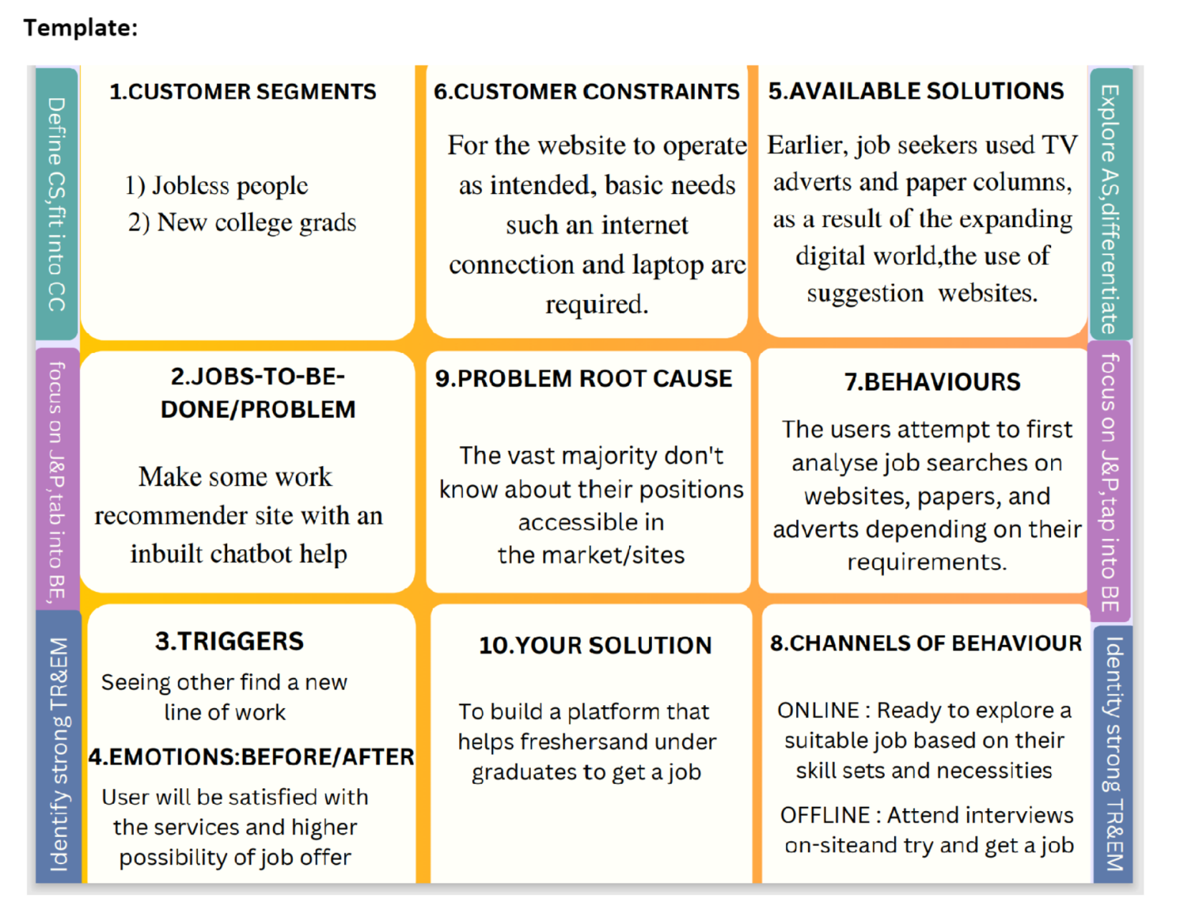

**4. REQUIREMENT ANALYSIS**

**4.1 Function Requirement**

**Software Required:**

Python, Flask, Docker

**4.2 Non-Function Requirement**

**System Required:**

8GB RAM, Intel Core i3, OS- Windows/Linux/MAC

,Laptop or Desktop

**5. PROJECT DESIGN**

**5.1 Data Flow Diagrams**

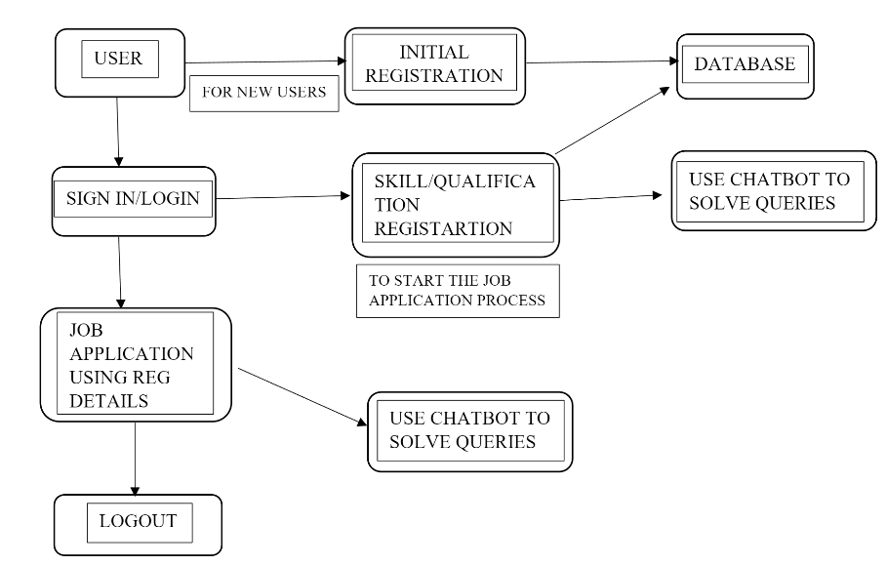

**5.2 Solution & Technical Architecture**

**SOLUTION ARCHITECTURE**

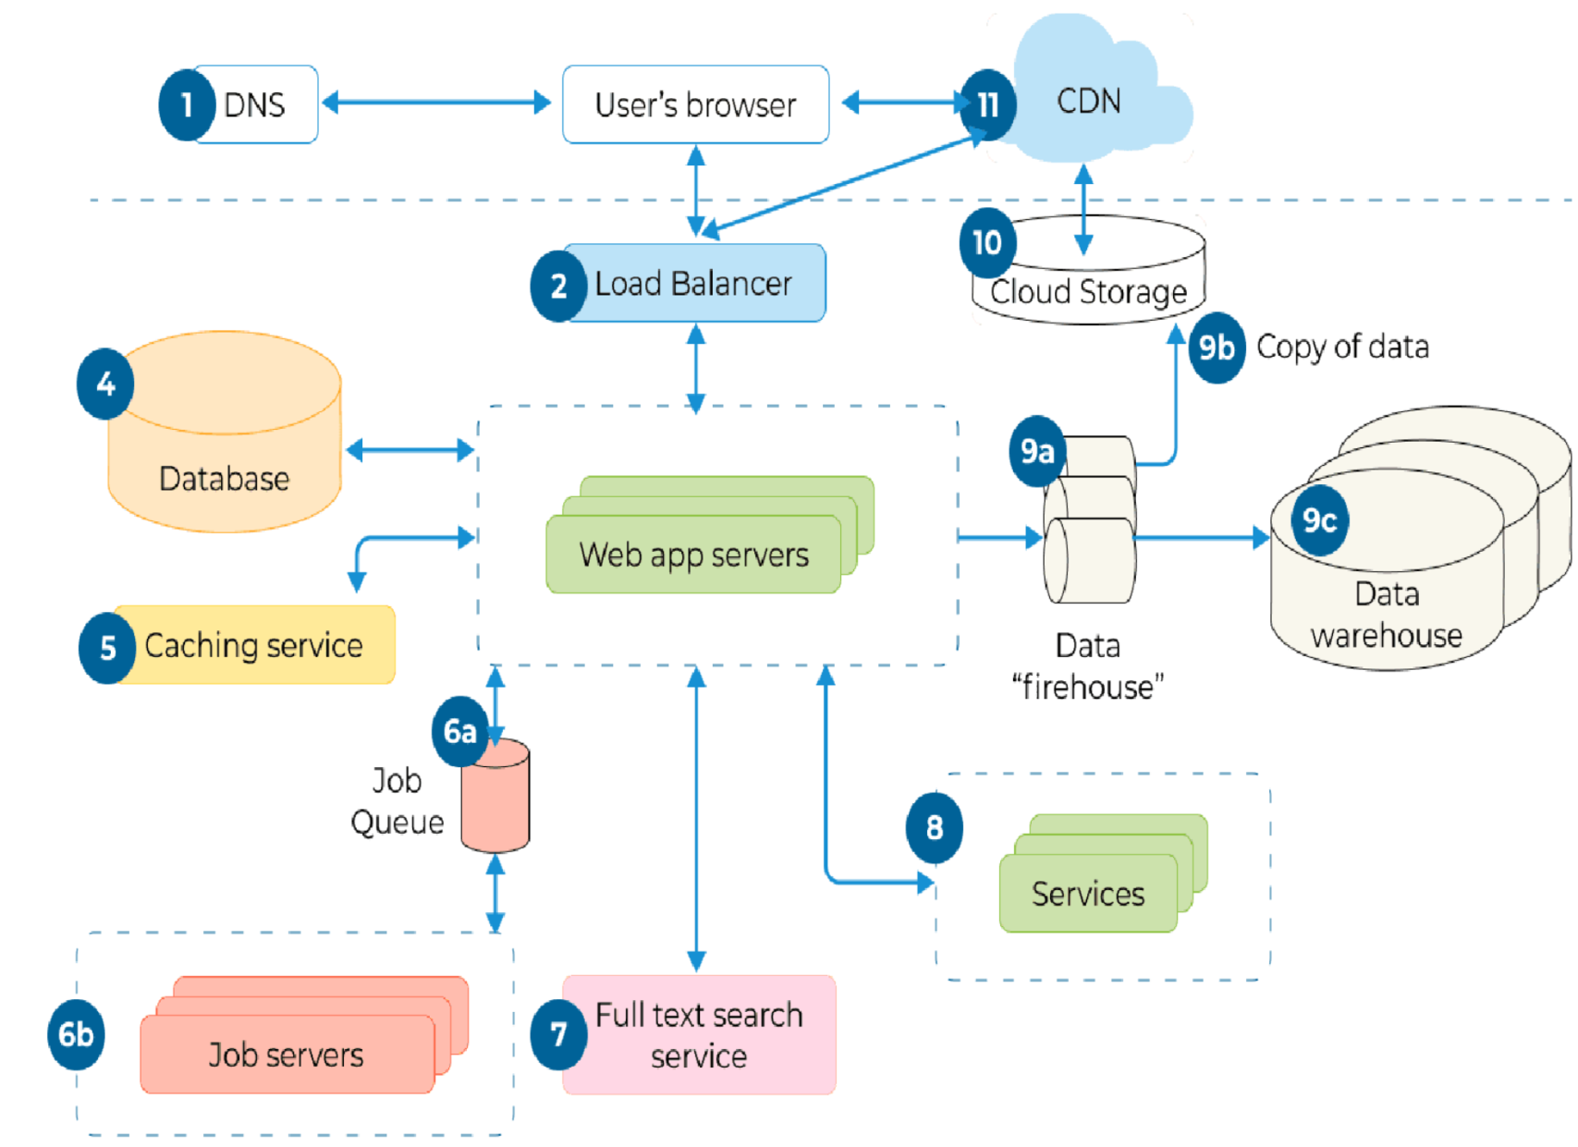

**TECHNICAL ARCHITECTURE**

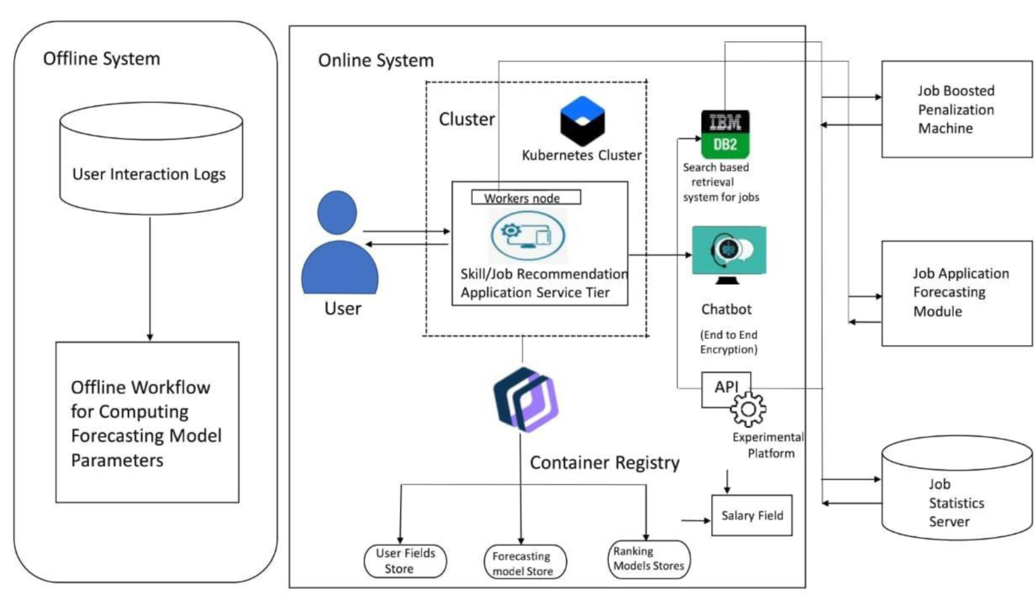

**5.3 User stories:**

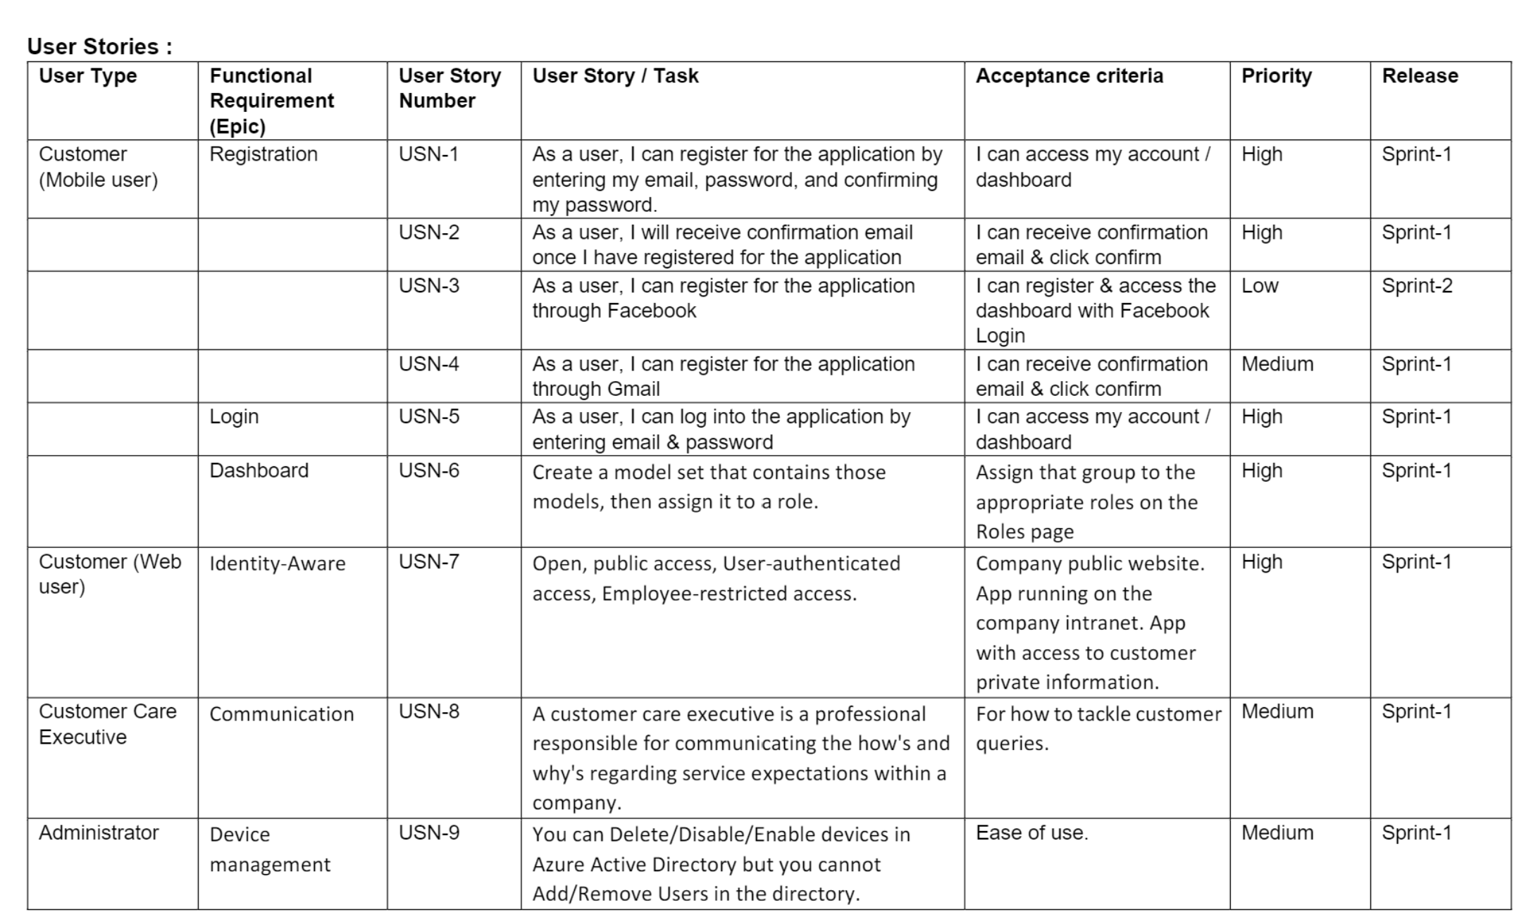

**6. PROJECT PLANNING & SCHEDULING**

**6.1 Sprint Planning & Estimation**

|  |  |  |  |  |  |  |
| --- | --- | --- | --- | --- | --- | --- |
| **Sprint** | **Functional Requirement (Epic)** | **User Story Number** | **User Story / Task** | **Priority** | **Acceptance criteria** | **Team Members** |
| Sprint-1 | UI Design | USN-1 | As a user, I can see and experience an awesome user interface in the website | Medium | Better Impression about a website | Vignesh.K |
| Sprint-1 | Registration | USN-2 | As a user, I can register for the application by entering my email, password, and confirming my password. | High | I can access my account *I*  dashboard | Vignesh.K |
| Sprint-1 |  | USN-3 | As a user, I will receive confirmation email once I have registered for the application | High | I can receive confirmation email &  click confirm | Vignesh.K |
| Sprint-1 |  | USN-4 | As a user, I can register for the application through Facebook | Low | I can register & access the dashboard with Facebook Login | Vignesh.K |
| Sprint-1 |  | USN-5 | As a user, I can register for the application through Gmail | Medium | I can receive confirmation email &  click confirm | Vignesh.K |
| Sprint-1 | Login | USN-6 | As a user, I can log into the application by entering email & password | High | I can access my account *I*  dashboard | Vignesh.K |

|  |  |  |  |  |  |  |
| --- | --- | --- | --- | --- | --- | --- |
| Sprint-! | Flask | USN-7 | As a user, I can access the website in a second | High | I can access my account *I*  dashboard | Vignesh.K |

|  |  |  |  |  |  |  |
| --- | --- | --- | --- | --- | --- | --- |
| **Sprint** | **Functional Requirement (Epic)** | **User Story**  **Number** | **User Story / Task** | **Priority** | **Acceptance criteria** | **Team Members** |
| Sprint-1 | Dashboard | USN-8 | As a user, If I Logged in correctly, I can view my dashboard and I can navigate to any pages which are already listed there. | High | I can access all the pages/ dashboard | Vignesh.K |
|  |  |  | Submission Of Sprint-1 |  |  |  |
| Sprint-2 | User Profile | USN-9 | As a user, I can view and update my details | Medium | I can modify my details/data | Mohammed Sugail.M |
| Sprint-2 | Database | USN-10 | As a user, I can store my details and data in the website w | Medium | I can store my data | Mohammed Sugail.M |
| Sprint-2 | Cloud Storage | USN-11 | As a user, I can upload my photo, resume and much more in the website. | Medium | I can Upload my documents and details | Mohammed Sugail.M |
| Sprint-2 | Chatbot | USN-12 | As a user, I can ask the Chatbot about latest job openings, which will help me and show the recent job openings based on my profile | High | I can know the recent job openings | Mohammed Sugail.M |

|  |  |  |  |  |  |  |
| --- | --- | --- | --- | --- | --- | --- |
| Sprint-2 | Identity-Aware | USN-13 | As a User, I can access my account by entering by correct login credentials. My user credentials is only displayed to me. | High | I can have my account safely | Mohammed Sugail.M |
|  |  |  | Submission of Sprint-2 |  |  |  |

|  |  |  |  |  |  |  |
| --- | --- | --- | --- | --- | --- | --- |
| **Sprint** | **Functional Requirement (Epic)** | **User Story Number** | **User Story / Task** | **Priority** | **Acceptance criteria** | **Team Members** |
| Sprint-3 | Sendgrid service | USN-14 | As a user, I can get a notification or mail about a job opening with the help of sendgrid service. | Medium | I can get a notification in a second. | Meenu.R |
| Sprint-3 | Learning Resource | USN-15 | As a user, I can learn the course and I will attain the skills which will be useful for developing my technical skills. | High | I can gain the knowledge and skills | Meenu.R |
| Sprint-3 | Docker | USN-16 | As a user, I can access the website in any device | High | I can access my account in any device | Meenu.R |
| Sprint-3 | Kubernates | USN-17 | As a user, I can access the website in any device | High | I can access my account in any device | Meenu.R |
| Sprint-3 | Deployment in cloud | USN-18 | As a user, I can access the website in any device | High | I can access my account in any device | Meenu.R |
| Sprint-3 | Technical support | USN-19 | As a user, I can get a customer care support from the website which will solve my queries. | Medium | I can tackle my problem & queries. | Meenu.R |

|  |  |  |  |  |  |  |
| --- | --- | --- | --- | --- | --- | --- |
|  |  |  | Submission of Sprint-3 |  |  |  |
| Sprint-4 | Unit Testing | USN-15 | As a user, I can access the website without any interruption | High | I can access the website without any interruption | Niranjana.S |
| Sprint-4 | Integration testing | USN-16 | As a user, I can access the website without any interruption | High | I can access the website without any interruption | Niranjana.S |

|  |  |  |  |  |  |  |
| --- | --- | --- | --- | --- | --- | --- |
| **Sprint** | **Functional Requirement (Epic)** | **User Story**  **Number** | **User Story / Task** | **Priority** | **Acceptance criteria** | **Team Members** |
| Sprint-4 | System testing | USN-17 | As a user, I can access the website without any interruption | High | I can access the website without any interruption | Niranjana.S |
| Sprint-4 | Correction | USN-18 | As a user, I can access the website without any interruption | High | I can access the website without any interruption | Niranjana.S |
| Sprint-4 | Acceptance testing | USN-19 | As a user, I can access the website without any interruption | High | I can access the website without any interruption | Niranjana.S |
|  |  |  | Submission of Sprint-4 |  |  |  |

**6.2 Sprint Delivery planning:**

Project Tracker, Velocity & Burndown Chart:

|  |  |  |  |  |  |  |
| --- | --- | --- | --- | --- | --- | --- |
| Sprint | Total Story Points | Duration | Sprint Start Date | Sprint End Date (Planned) | Story Points Completed (as on Planned End Date) | Sprint Release Date (Actual) |
| Sprint-1 | 20 | 6 Days | 24 Oct 2022 | 29 Oct 2022 | 20 | 06 Nov 2022 |
| Sprint-2 | 20 | 6 Days | 31 Oct 2022 | 05 Nov 2022 | 20 | 10 Nov 2022 |
| Sprint-3 | 20 | 6 Days | 07 Nov 2022 | 12 Nov 2022 | 20 | 15 Nov 2022 |
| Sprint-4 | 20 | 6 Days | 14 Nov 2022 | 19 Nov 2022 | 20 | 19 Nov 2022 |

# Velocity:

Imagine we have a 10-day sprint duration, and the velocity of the team is 20 (points per sprint). Let's calculate the team's average velocity (AV) per iteration unit (story points per day)

**6.3 Report from JIRA**

*AV sprint duration* 20 2 *velocity* 10

**7. CODING & SOLUTIONING**

**7.1 Feature 1**

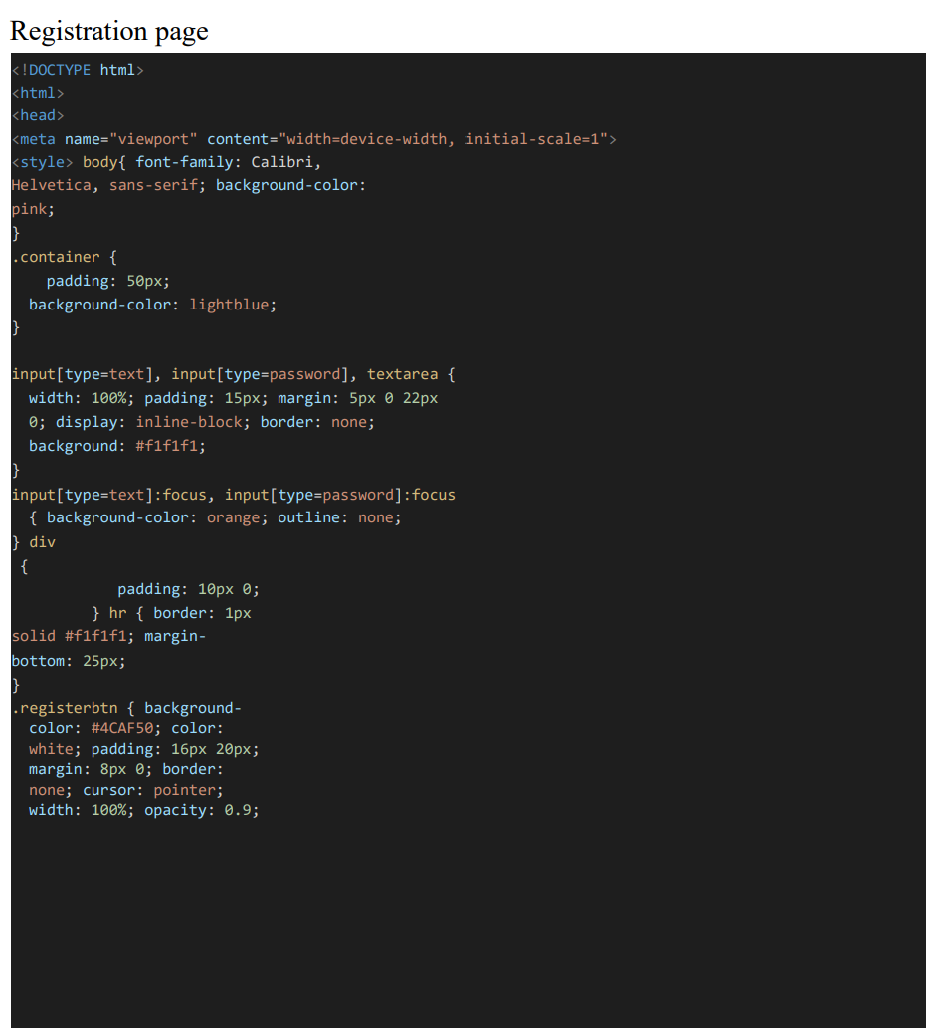

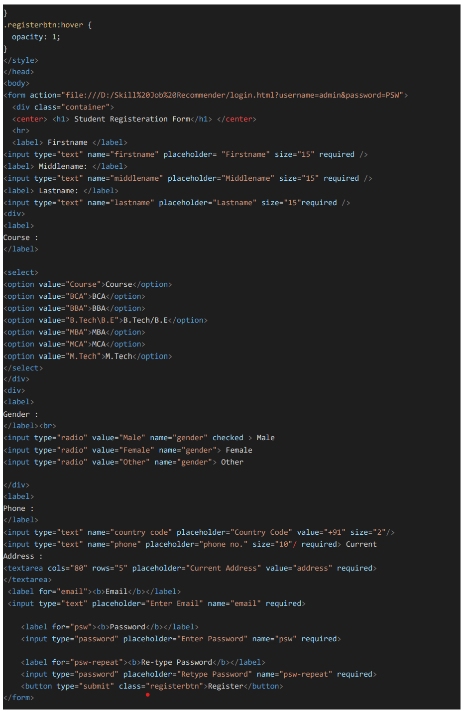



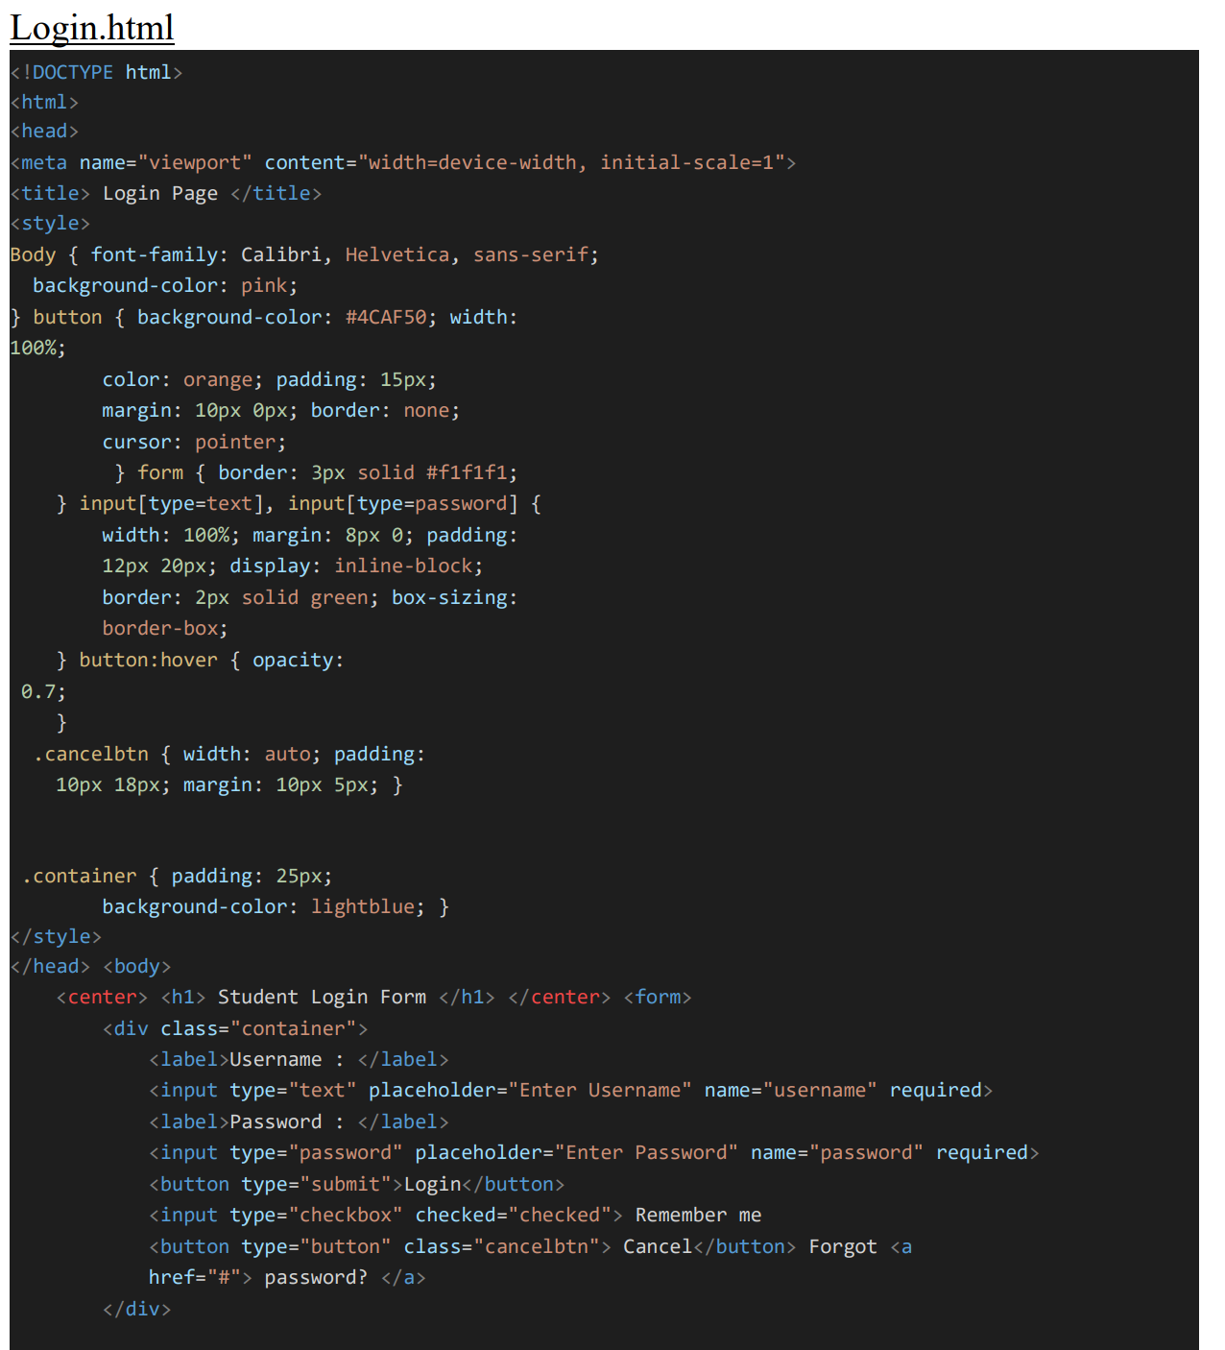



**7.2 Feature 2**

import { useToast } from "@chakra-ui/react";

import React, { useContext } from "react";

import { Link, useNavigate } from "react-router-dom";

import { AppContext } from "../context/AppContext";

const Navbar = () => {

const navigate = useNavigate();

const toast = useToast();

const { user, setUser, setSkills } = useContext(AppContext);

const logout = () => {

setUser(null);

setSkills([]);

toast({

title: "Logged out successfully!",

status: "info",

duration: 3000,

isClosable: true,

variant: "left-accent",

position: "top",

});

localStorage.removeItem("user");

navigate("/");

};

return (

<div className="navbar bg-base-100 border-b-2">

<div className="flex-1">

<Link

className="btn btn-ghost normal-case text-xl"

to={user ? "/dashboard" : "/"}

>

F-ing Jobs

</Link>

</div>

{user && (

<div className="flex-none gap-2">

<div className="dropdown dropdown-end">

<label tabIndex={0} className="btn btn-ghost btn-circle avatar ">

<div className="w-10 rounded-full ring ring-opacity-50 ring-purple-700">

<img src="https://placeimg.com/80/80/people" />

</div>

</label>

<ul

tabIndex={0}

className="mt-3 p-2 shadow menu menu-compact dropdown-content bg-base-100 rounded-box w-52"

>

<li>

<a

className="justify-between"

onClick={() => navigate("/profile")}

>

Profile

</a>

</li>

<li>

<a onClick={logout}>Logout</a>

</li>

</ul>

</div>

</div>

)}

</div>

);

};

export default Navbar;

**CHATBOT :**

Chatbot has been implemented to provide assistance .

window.watsonAssistantC hatOptions = { integrationID: "d73273d3-3f44-430484ee-8fd243016d1d", // The ID of this integration.

region: "jp-tok",

// The region your integration is hosted in.

serviceInstanceID: "81229104-ee6b-46daac1c-67ede110663a", // The ID of your service instance.

onLoad: function(instance) {

instance.render(); }

};

setTimeout(function(){

const t=document.createElement('script');

t.src="https://webchat.global.assistant.watson.appdomain. cloud/versions/" +

(window.watsonAssistantChatOptions.clie ntVersion || 'latest') +

"/WatsonAssistantChatEntry.js"; document.head.appendChild(t);

});

**7.3 Database Schema(if Applicable) :**

# using SendGrid's Python Library

# https://github.com/sendgrid/sendgrid-python

import os

from sendgrid import SendGridAPIClient

from sendgrid.helpers.mail import Mail

# from_address we pass to our Mail object, edit with your name

FROM_EMAIL = 'Your_Name@SendGridTest.com'

def SendEmail(to_email):

""" Send an email to the provided email addresses

:param to_email = email to be sent to

:returns API response code

:raises Exception e: raises an exception """

message = Mail(

from_email=FROM_EMAIL,

to_emails=to_email,

subject='A Test from SendGrid!',

html_content='<strong>Hello there from SendGrid your URL is: ' +

'<a href=''https://github.com/cyberjive''>right here!</a></strong>')

try:

sg = SendGridAPIClient(os.environ.get('SENDGRID_API_KEY'))

response = sg.send(message)

code, body, headers = response.status_code, response.body, response.headers

print(f"Response Code: {code} ")

print(f"Response Body: {body} ")

print(f"Response Headers: {headers} ")

print("Message Sent!")

except Exception as e:

print("Error: {0}".format(e))

return str(response.status_code)

if __name__ == "__main__":

SendEmail(to_email=input("Email address to send to? "))

**8. TESTING**

|  |  |  |  |  |  |  |  |  |  |  |  |  |  |  |  |  |  |  |  |  |  |  |  |  |  |  |  |  |  |  |  |  |  |  |  |  |  |  |  |  |  |  |  |  |  |  |  |  |  |  |  |  |  |  |  |  |  |  |  |  |  |  |  |  |  |  |  |  |  |  |  |  |  |  |  |  |  |  |  |  |  |  |  |  |  |  |  |  |  |  |  |  |  |  |  |  |  |  |  |  |  |  |  |  |  |  |  |  |  |  |  |  |  |  |  |  |  |  |  |  |  |  |  |  |  |  |  |  |  |  |  |  |  |  |  |  |  |  |  |  |  |  |  |  |  |  |  |  |  |  |  |  |  |  |  |  |  |  |  |  |  |  |  |  |  |  |  |  |  |  |  |  |  |  |  |  |  |  |  |  |  |  |  |  |  |  |  |  |  |  |  |  |  |  |  |
| --- | --- | --- | --- | --- | --- | --- | --- | --- | --- | --- | --- | --- | --- | --- | --- | --- | --- | --- | --- | --- | --- | --- | --- | --- | --- | --- | --- | --- | --- | --- | --- | --- | --- | --- | --- | --- | --- | --- | --- | --- | --- | --- | --- | --- | --- | --- | --- | --- | --- | --- | --- | --- | --- | --- | --- | --- | --- | --- | --- | --- | --- | --- | --- | --- | --- | --- | --- | --- | --- | --- | --- | --- | --- | --- | --- | --- | --- | --- | --- | --- | --- | --- | --- | --- | --- | --- | --- | --- | --- | --- | --- | --- | --- | --- | --- | --- | --- | --- | --- | --- | --- | --- | --- | --- | --- | --- | --- | --- | --- | --- | --- | --- | --- | --- | --- | --- | --- | --- | --- | --- | --- | --- | --- | --- | --- | --- | --- | --- | --- | --- | --- | --- | --- | --- | --- | --- | --- | --- | --- | --- | --- | --- | --- | --- | --- | --- | --- | --- | --- | --- | --- | --- | --- | --- | --- | --- | --- | --- | --- | --- | --- | --- | --- | --- | --- | --- | --- | --- | --- | --- | --- | --- | --- | --- | --- | --- | --- | --- | --- | --- | --- | --- | --- | --- | --- | --- | --- | --- | --- | --- | --- | --- | --- | --- | --- |
| **8.2 User Acceptance Testing** **➢ Purpose of Document** The purpose of this document is to briefly explain the test coverage and open issues of  the Skills/Job Recommender.  Application project at the time of the release to User Acceptance Testing (UAT).  **➢ Defect Analysis**  This report shows the number of resolved or closed bugs at each severity level, and how they  were resolved.         |  |  |  |  |  |  |  |  |  |  |  |  | | --- | --- | --- | --- | --- | --- | --- | --- | --- | --- | --- | --- | | **Section** | | | | **Total Cases** | | **Not Tested** | | **Fail** | | **Pass** |  | | Print Engine | | | | 7 | | 0 | | 0 | | 7 | | | Client Application | | | | 5 | | 0 | | 0 | | 5 | | | Security | | | | 3 | | 0 | | 0 | | 3 | | | Outsource Shipping | | | | 7 | | 0 | | 0 | | 7 | | |  | **Resolution** | **Severity 1** | **Severity 2** | | **Severity 3** | **Severity 4** | | | **Subtotal** | | | | By Design | | 3 | 2 | | 1 | 1 | | | 7 | | | | Duplicate | | 1 | 0 | | 2 | 0 | | | 3 | | | | External | | 2 | 0 | | 0 | 1 | | | 3 | | | | Fixed | | 5 | 2 | | 5 | 7 | | | 19 | | | | Not Reproduced | | 0 | 0 | | 1 | 0 | | | 1 | | | | Skipped | | 0 | 0 | | 0 | 1 | | | 1 | | | | Won't Fix | | 0 | 5 | | 1 | 1 | | | 7 | | | | Totals | | 11 | 9 | | 10 | 11 | | | 41 | | | |  |  |  |  | |  |  |  |  |  |  |  |    1.**Test Case Analysis** This report shows the number of test cases that have passed, failed, and untested     |  |  |  |  |  | | --- | --- | --- | --- | --- | | Exception Reporting | 6 | 0 | 0 | 6 | | Final Report Output | 3 | 0 | 0 | 3 | | Version Control | 2 | 0 | 0 | 2 |     **9. RESULTS**  The project has been completed as we expected.We ensured that Database was designed  and well connected to our project.The Expected results were gotten.    **10. ADVANTAGES & DISADVANTAGES**  **ADVANTAGES:**  ➢ Person who looks for a job can easily find a suitable job based on their skill set.  ➢ Person can check their eligibility by attending eligibility test.  ➢ Most of the Recruiters find the suitable person based on the scores they have  gotten in the eligibility.    **DISADVANTAGES**  ➢Person Job May get technical difficulty while taking the eligibility    ➢ Job seeker may have trouble to contact recruiters directly.      **11. CONCLUSION**  The application has been developed to make job search easier .The application that  we have developed is user friendly .User can find a job based on their skillset in the  short period of time. The jobseeker certainly get benefit by using this application.  In the addition,Chatbot Has been implemented with the help of IBM whatson . The  chatbot helps jobseeker and organization when they experience the difficulties.    **12. FUTURE SCOPE**  The linked in the wellknown application to find a job and stay connected with  professional and organization.The job seekers and organization use linked in to find  a job.In the future , There are lots of possibilities to enhance our project similar to linkedin.    **13. APPENDIX**  **SOURCE CODE**  **__init__.py**  from dotenv import dotenv_values  from flask import Flask  from flask_cors import CORS  import ibm_db  # Get the environment variables  config = dotenv_values("backend/.env")  # Connect to db  try:  # conn = 'dd'  conn = ibm_db.pconnect(  f"DATABASE={config['DB2_DATABASE']};HOSTNAME={config['DB2_HOSTNAME']};  PORT={config['DB2_PORT']};SECURITY=SSL; SSLServerCertificate=backend/  DigiCertGlobalRootCA.crt;UID={config['DB2_USERNAME']};  PWD={config['DB2_PASSWORD']}", '', '')  print("Connected to IBM_DB2 successfully!!")  print(conn)  except:  print("Failed to connect to Database!")  def create_app():  # Tell flask to use the build directory of react to serve static content  app = Flask(__name__, static_folder='../build', static_url_path='/')  CORS(app)  # Set the secret key for flask  app.config['SECRET_KEY'] = config['APP_SECRET']  # Import and register auth_router  from .auth_router import auth  app.register_blueprint(auth, url_prefix='/api/auth')  from .files_router import files  app.register_blueprint(files, url_prefix='/api/files')  from .user_router import user  app.register_blueprint(user, url_prefix='/api/user')  # In production serve the index.html page at root  @app.route("/")  def home():  return app.send_static_file('index.html')  return app **auth_middleware.py** from functools import wraps  import jwt  from flask import request  from backend import conn, config  import ibm_db  # Middleware function that checks for JWT token in header  # All routes that have the @token_required decorator will be protected  def token_required(f):  @wraps(f)  def decorated(*args, **kwargs):  token = None  if "Authorization" in request.headers:  token = request.headers["Authorization"].split(" ")[1]  if not token:  return {  "error": "Unauthorized"  }, 401  try:  # Get the user's email from the decoded token  data = jwt.decode(  token, config["APP_SECRET"], algorithms=["HS256"])  # Retreive user's info from the database  sql = f"select * from users where email='{data['email']}'"  stmt = ibm_db.prepare(conn, sql)  ibm_db.execute(stmt)  current_user = ibm_db.fetch_assoc(stmt)  # If user does not exist throw error.  if current_user is None:  return {  "error": "Unauthorized"  }, 401  except Exception as e:  return {  "error": str(e)  }, 500  # Pass the authorized user in function args.  return f(current_user, *args, **kwargs)  return decorated |

## **auth_router.py**

from flask import Blueprint, jsonify, request

from backend import conn, config

import bcrypt

import jwt

import ibm_db

auth = Blueprint("auth", __name__)

LOGIN_FEILDS = ('email', 'password')

SIGNUP_FEILDS = ('name', 'email', 'phone_number', 'password')

@auth.route("/login", methods=['POST'])

def login_user():

# Check if all the required feild are present

for feild in LOGIN_FEILDS:

if not (feild in request.json):

return jsonify({"error": f"All feilds are required!"}), 409

email = request.json['email']

password = request.json['password']

sql = f"select * from users where email='{email}'"

stmt = ibm_db.prepare(conn, sql)

ibm_db.execute(stmt)

user = ibm_db.fetch_assoc(stmt)

if not user:

return jsonify({"error": "Invalid credentials!"}), 401

if bcrypt.checkpw(password.encode('utf-8'),

user["PASSWORD"].encode('utf-8')):

token = jwt.encode(

{"email": email},

config["APP_SECRET"],

algorithm="HS256"

)

return jsonify({"name": user["NAME"], "email": email, "phone_number": user["PHONE_NUMBER"], "token": token}), 200

else:

return jsonify({"error": "Invalid credentials!"}), 401

@auth.route("/signup", methods=['POST'])

def register_user():

# Check if all the required feild are present

for feild in SIGNUP_FEILDS:

if not (feild in request.json):

return jsonify({"error": f"All feilds are required!"}), 409

email = request.json['email']

phone_number = request.json['phone_number']

name = request.json['name']

password = request.json['password']

# Sql stmt to check if email/number is already in use

sql = f"select * from users where email='{email}' or phone_number='{phone_number}'"

stmt = ibm_db.prepare(conn, sql)

ibm_db.execute(stmt)

user = ibm_db.fetch_assoc(stmt)

if user:

return jsonify({"error": f"Email/Phone number is alread in use!"}), 409

# If user does not exist, then create account

hashed_password = bcrypt.hashpw(

password.encode('utf-8'), bcrypt.gensalt())

sql = f"insert into users(name,email,phone_number,password) values('{name}','{email}','{phone_number}',?)"

stmt = ibm_db.prepare(conn, sql)

ibm_db.bind_param(stmt, 1, hashed_password)

ibm_db.execute(stmt)

token = jwt.encode(

{"email": email},

config["APP_SECRET"],

algorithm="HS256"

)

return jsonify({"name": name, "email": email, "phone_number": phone_number, "token": token}), 200

## **files_router.py**

from flask import Blueprint

from backend.auth_middleware import token_required

import ibm_boto3

from ibm_botocore.client import Config, ClientError

from backend import config

cos = ibm_boto3.resource("s3",

ibm_api_key_id=config["COS_API_KEY_ID"],

ibm_service_instance_id=config["COS_INSTANCE_CRN"],

config=Config(signature_version="oauth"),

endpoint_url=config["COS_ENDPOINT"]

)

files = Blueprint("files", __name__)

def multi_part_upload(bucket_name, item_name, file_path):

try:

print("Starting file transfer for {0} to bucket: {1}\n".format(

item_name, bucket_name))

# set 5 MB chunks

part_size = 1024 * 1024 * 5

# set threadhold to 15 MB

file_threshold = 1024 * 1024 * 15

# set the transfer threshold and chunk size

transfer_config = ibm_boto3.s3.transfer.TransferConfig(

multipart_threshold=file_threshold,

multipart_chunksize=part_size

)

# the upload_fileobj method will automatically execute a multi-part upload

# in 5 MB chunks for all files over 15 MB

with open(file_path, "rb") as file_data:

cos.Object(bucket_name, item_name).upload_fileobj(

Fileobj=file_data,

Config=transfer_config

)

print("Transfer for {0} Complete!\n".format(item_name))

except ClientError as be:

print("CLIENT ERROR: {0}\n".format(be))

except Exception as e:

print("Unable to complete multi-part upload: {0}".format(e))

@files.route('/avatar', methods=["POST"])

@token_required

def upload_profile_photo(current_user):

return "hello"

## **user_router.py**

from flask import Blueprint, jsonify, request

from backend import conn

from backend.auth_middleware import token_required

import ibm_db

user = Blueprint("user", __name__)

@user.route("/skills", methods=["GET", "POST", "DELETE"])

@token_required

def manage_skills(current_user):

# Get user_id of current user

user_id = current_user['USER_ID']

# Handle GET request

if request.method == 'GET':

skills = []

sql = f"select name from skills where user_id={user_id}"

stmt = ibm_db.prepare(conn, sql)

ibm_db.execute(stmt)

dict = ibm_db.fetch_assoc(stmt)

# Iterate over all the results and append skills to the array

while dict != False:

skills.append(dict['NAME'])

dict = ibm_db.fetch_assoc(stmt)

return jsonify({"skills": skills}), 200

# Get the skills from the request

if not ('skills' in request.json):

return jsonify({"error": f"All feilds are required!"}), 409

skills = request.json['skills']

# If no skills are provided then return empty array

if skills == []:

return jsonify({"skills": []}), 200

# Handle POST request

if request.method == "POST":

# Prepare the SQL statement to insert multiple rows

values = ''

for i in range(len(skills)):

if i == 0:

values += 'values'

values += f"('{skills[i]}',{user_id})"

if i != len(skills)-1:

values += ','

sql = f"insert into skills(name,user_id) {values}"

stmt = ibm_db.prepare(conn, sql)

status = ibm_db.execute(stmt)

if status:

return jsonify({"message": "Updated skills successfully!"}), 200

else:

jsonify({"error": "Something went wrong!!"}), 409

# Handle DELETE request

if request.method == 'DELETE':

values = ""

for i in range(len(skills)):

values += f"'{skills[i]}'"

if i != len(skills)-1:

values += ','

sql = f"delete from skills where name in ({values})"

stmt = ibm_db.prepare(conn, sql)

status = ibm_db.execute(stmt)

if status:

return jsonify({"message": "Deleted skills successfully!"}), 200

else:

jsonify({"error": "Something went wrong!!"}), 409

**avatar.svg**

<svg width="480" height="480" fill="none" xmlns="http://www.w3.org/2000/svg"><rect opacity=".1" width="480" height="480" rx="32" fill="#fff"/><path d="M374.308 240c0 71.691-58.117 129.808-129.808 129.808S114.692 311.691 114.692 240 172.809 110.192 244.5 110.192 374.308 168.309 374.308 240z" fill="#F6F6F6" stroke="#fff" stroke-width="10.385"/><path fill-rule="evenodd" clip-rule="evenodd" d="M244.5 256.2c-21.627 0-64.8 10.854-64.8 32.4v16.2h129.6v-16.2c0-21.546-43.173-32.4-64.8-32.4m0-16.2c17.901 0 32.4-14.499 32.4-32.4 0-17.901-14.499-32.4-32.4-32.4-17.901 0-32.4 14.499-32.432.4 0 17.901 14.499 32.4 32.4 32.4" fill="#35374A" opacity=".3"/></svg>

## **JobCard.jsx**

import React, { useEffect } from "react";

const JobCard = ({ title, company, description, link }) => {

return (

<div className="max-w-sm flex flex-col rounded overflow-hidden shadow-lg border-2 border-slate-200">

<>

<div className="px-6 py-4">

<div className="font-bold text-xl">{title}</div>

<div className="text mb-2 text-gray-400">{company}</div>

<p className="text-ellipsis overflow-hidden text-gray-800 text-sm">

{description}

</p>

</div>

<div className="px-6 pt-4 pb-2 mt-auto mb-2">

<a

href={link}

target="__blank"

className="bg-transparent hover:bg-purple-400 text-purple-400 font-semibold hover:text-white py-2 mb-0 mt-4 px-4 border border-purple-400 hover:border-transparent rounded"

>

Apply

</a>

</div>

</>

</div>

);

};

export default JobCard;

## **Login.jsx**

import React, { useContext, useState } from "react";

import { Link, useNavigate } from "react-router-dom";

import { AppContext } from "../context/AppContext";

import { loginUser } from "../proxies/backend_api";

import { emailRegex } from "../utils/helper";

const Login = () => {

const { setShowAlert, setUser } = useContext(AppContext);

const navigate = useNavigate();

const [inputs, setInputs] = useState({

email: "",

password: "",

});

const [error, setErrors] = useState({

email: "",

password: "",

});

const handleChange = ({ target: { name, value } }) => {

setErrors((prev) => {

return { ...prev, [name]: "" };

});

setInputs((prev) => ({ ...prev, [name]: value }));

};

const checkInputErrors = () => {

let status = true;

if (inputs.email.trim() === "" || !emailRegex.test(inputs.email.trim())) {

setErrors((prev) => {

return { ...prev, email: "Enter a valid email" };

});

status = false;

}

if (inputs.password.trim() === "") {

setErrors((prev) => {

return { ...prev, password: "Enter a valid password" };

});

status = false;

}

if (inputs.password.trim().length < 6) {

setErrors((prev) => {

return { ...prev, password: "Minimum 6 characters" };

});

status = false;

}

return status;

};

const handleLogin = async () => {

if (checkInputErrors()) {

const data = await loginUser(inputs);

if (data.error) {

setShowAlert({ type: "error", message: data.error, duration: 3000 });

return;

}

setUser(data);

setShowAlert({

type: "success",

message: `Welcome back ${data.name}`,

duration: 3000,

});

localStorage.setItem("user", JSON.stringify(data));

navigate("/dashboard");

}

};

return (

<div className="flex flex-col justify-center items-center gap-10 mt-5">

<div>

<button className="bg-base-300 rounded-box flex flex-row justify-evenly items-center gap-10 px-10 py-5 w-fit mx-auto">

<span>Sign in with Github</span>

<img src={`github-dark.png`} alt="github" width="14%" />

</button>

<div className="divider max-w-xs">or</div>

<form

onSubmit={(e) => e.preventDefault()}

className="card bg-base-300 rounded-box flex flex-col justify-center items-center gap-5 px-10 py-5 w-fit mx-auto"

>

<div>

<input

value={inputs.email}

type="text"

name="email"

placeholder="email"

className="input input-bordered input-primary w-full"

onChange={handleChange}

/>

{error.email !== "" && (

<p className="text-sm text-red-500 mt-1 font-medium">

{error.email}

</p>

)}

</div>

<div>

<input

value={inputs.password}

type="password"

name="password"

placeholder="password"

className="input input-bordered input-primary w-full"

onChange={handleChange}

/>

{error.password !== "" && (

<p className="text-sm text-red-500 mt-1 font-medium">

{error.password}

</p>

)}

</div>

<div className="text-center">

<button

type="submit"

onClick={handleLogin}

className="btn btn-sm btn-primary mb-4"

>

Login

</button>

<p>

Don't have an account?{" "}

<Link className="text-blue-400" to="/signup">

Sign up

</Link>

</p>

</div>

</form>

</div>

</div>

);

};

export default Login;

## **Navbar.jsx**

import { useToast } from "@chakra-ui/react";

import React, { useContext } from "react";

import { Link, useNavigate } from "react-router-dom";

import { AppContext } from "../context/AppContext";

const Navbar = () => {

const navigate = useNavigate();

const toast = useToast();

const { user, setUser, setSkills } = useContext(AppContext);

const logout = () => {

setUser(null);

setSkills([]);

toast({

title: "Logged out successfully!",

status: "info",

duration: 3000,

isClosable: true,

variant: "left-accent",

position: "top",

});

localStorage.removeItem("user");

navigate("/");

};

return (

<div className="navbar bg-base-100 border-b-2">

<div className="flex-1">

<Link

className="btn btn-ghost normal-case text-xl"

to={user ? "/dashboard" : "/"}

>

F-ing Jobs

</Link>

</div>

{user && (

<div className="flex-none gap-2">

<div className="dropdown dropdown-end">

<label tabIndex={0} className="btn btn-ghost btn-circle avatar ">

<div className="w-10 rounded-full ring ring-opacity-50 ring-purple-700">

<img src="https://placeimg.com/80/80/people" />

</div>

</label>

<ul

tabIndex={0}

className="mt-3 p-2 shadow menu menu-compact dropdown-content bg-base-100 rounded-box w-52"

>

<li>

<a

className="justify-between"

onClick={() => navigate("/profile")}

>

Profile

</a>

</li>

<li>

<a onClick={logout}>Logout</a>

</li>

</ul>

</div>

</div>

)}

</div>

);

};

export default Navbar;

## **SearchBar.jsx**

import React from "react";

import { BsSearch } from "react-icons/bs";

const SearchBar = ({ setquery, onClick }) => {

const handlesubmit = (e) => {

e.preventDefault();

onClick();

};

return (

<form className="flex items-center" onSubmit={handlesubmit}>

<label htmlFor="simple-search" className="sr-only">

Search

</label>

<div className="relative w-full">

<div className="flex absolute inset-y-0 left-0 items-center pl-3 pointer-events-none">

<BsSearch />

</div>

<input

onChange={(e) => setquery(e.target.value)}

name="search"

type="text"

id="simple-search"

className="bg-gray-50 border border-gray-300 text-gray-900 text-sm rounded-lg focus:ring-blue-500 focus:border-blue-500 block w-full pl-10 p-2.5 dark:bg-gray-700 dark:border-gray-600 dark:placeholder-gray-400 dark:text-white dark:focus:ring-blue-500 dark:focus:border-blue-500"

placeholder="Search"

required=""

/>

</div>

<button

type="submit"

className="p-2.5 ml-2 text-sm font-medium text-white bg-purple-700 rounded-lg border border-purple-700 hover:bg-purple-800 focus:ring-4 focus:outline-none focus:ring-purple-300"

>

<BsSearch />

<span className="sr-only">Search</span>

</button>

</form>

);

};

export default SearchBar;

## **Signup.jsx**

import React, { useContext, useEffect, useState } from "react";

import { useNavigate } from "react-router-dom";

import { AppContext } from "../context/AppContext";

import { registerUser } from "../proxies/backend_api";

import { emailRegex } from "../utils/helper";

const SignUp = () => {

const { setUser } = useContext(AppContext);

const navigate = useNavigate();

const [inputs, setInputs] = useState({

name: "",

email: "",

phone_number: "",

password: "",

confirm_password: "",

});

const [error, setErrors] = useState({

name: "",

email: "",

phone_number: "",

password: "",

confirm_password: "",

});

const handleChange = ({ target: { name, value } }) => {

setErrors((prev) => {

return { ...prev, [name]: "" };

});

setInputs((prev) => ({ ...prev, [name]: value }));

};

const checkInputErrors = () => {

let status = true;

if (inputs.email.trim() === "" || !emailRegex.test(inputs.email.trim())) {

setErrors((prev) => {

return { ...prev, email: "Enter a valid email" };

});

status = false;

}

if (inputs.name.trim() === "") {

setErrors((prev) => {

return { ...prev, name: "Enter a valid name" };

});

status = false;

}

if (inputs.phone_number.trim() === "") {

setErrors((prev) => {

return { ...prev, phone_number: "Enter a valid phone number" };

});

status = false;

}

if (inputs.confirm_password.trim() === "") {

setErrors((prev) => {

return { ...prev, confirm_password: "Enter a valid password" };

});

status = false;

}

if (inputs.password.trim() === "") {

setErrors((prev) => {

return { ...prev, password: "Enter a valid password" };

});

status = false;

}

if (inputs.password.trim().length < 6) {

setErrors((prev) => {

return { ...prev, password: "Minimum 6 characters" };

});

status = false;

}

if (inputs.password.trim() !== inputs.confirm_password.trim()) {

setErrors((prev) => {

return { ...prev, confirmPassword: "Password don't match" };

});

status = false;

}

return status;

};

const handleSignUp = async () => {

if (checkInputErrors()) {

const data = await registerUser(inputs);

if (data.error) {

toast({

title: data.error,

status: "error",

duration: 3000,

isClosable: true,

variant: "left-accent",

position: "top",

});

return;

}

setUser(data);

toast({

title: `Your journey starts here ${data.name}`,

status: "success",

duration: 3000,

isClosable: true,

variant: "left-accent",

position: "top",

});

localStorage.setItem("user", JSON.stringify(data));

navigate("/profile");

}

};

return (

<>

<div>

<button className="bg-base-300 rounded-box flex flex-row justify-evenly items-center gap-10 px-10 py-5 w-fit mx-auto">

<span>Sign in with Github</span>

<img src={`github-dark.png`} alt="github" width="14%" />

</button>

<div className="divider max-w-xs">or</div>

<div className="card bg-base-300 rounded-box flex flex-col justify-center items-center gap-3 px-10 py-5 w-fit mx-auto">

<div>

<input

value={inputs.name}

type="text"

name="name"

placeholder="name"

className="input input-bordered input-primary w-full"

onChange={handleChange}

/>

{error.name !== "" && (

<p className="text-sm text-red-500 font-medium">{error.name}</p>

)}

</div>

<div>

<input

value={inputs.email}

type="text"

name="email"

placeholder="email"

className="input input-bordered input-primary w-full"

onChange={handleChange}

/>

{error.email !== "" && (

<p className="text-sm text-red-500 font-medium">{error.email}</p>

)}

</div>

<div>

<input

value={inputs.phone_number}

type="text"

name="phone_number"

placeholder="phone number"

className="input input-bordered input-primary w-full"

onChange={handleChange}

/>

{error.phone_number !== "" && (

<p className="text-sm text-red-500 font-medium">

{error.phone_number}

</p>

)}

</div>

<div>

<input

value={inputs.password}

type="password"

name="password"

placeholder="password"

className="input input-bordered input-primary w-full"

onChange={handleChange}

/>

{error.password !== "" && (

<p className="text-sm text-red-500 font-medium">

{error.password}

</p>

)}

</div>

<div>

<input

value={inputs.confirm_password}

type="password"

name="confirm_password"

placeholder="confirm password"

className="input input-bordered input-primary w-full"

onChange={handleChange}

/>

{error.confirm_password !== "" && (

<p className="text-sm text-red-500 font-medium">

{error.confirm_password}

</p>

)}

</div>

<div className="text-center">

<button

onClick={handleSignUp}

className="btn btn-sm btn-primary mb-4"

>

Sign Up

</button>

</div>

</div>

</div>

</>

);

};

export default SignUp;

**Skill.jsx**

import React, { useEffect, useState } from "react";

const Skill = ({ skill, setSelectedSkills, disabled }) => {

const [isSelected, setIsSelected] = useState(false);

useEffect(() => {

if (isSelected) {

setSelectedSkills((prev) => [...prev, skill]);

} else {

setSelectedSkills((prev) => prev.filter((item) => item !== skill));

}

}, [isSelected]);

return (

<li className="hover:text-white flex gap-1 items-center justify-between p-1 rounded-sm">

{skill}

<button

disabled={disabled}

onClick={() => setIsSelected(!isSelected)}

className={`cursor-pointer border-2 ${

!isSelected ? "border-green-500" : "border-red-400"

} p-1 rounded-lg`}

>

{!isSelected ? "Add" : "Remove"}

</button>

</li>

);

};

export default Skill;

## **AppContext.jsx**

import { createContext, useEffect, useState } from "react";

import { useNavigate } from "react-router-dom";

export const AppContext = createContext();

export const AppProvider = ({ children }) => {

const navigate = useNavigate();

const [skills, setSkills] = useState([]);

const [user, setUser] = useState(null);

useEffect(() => {

let temp_user = JSON.parse(localStorage.getItem("user"));

if (!temp_user) {

navigate("/");

} else {

setUser(temp_user);

}

}, []);

return (

<AppContext.Provider value={{ user, setUser, skills, setSkills }}>

{children}

</AppContext.Provider>

);

};

## **backend_api.js**

import { BASE_URL } from "../utils/helper";

export const loginUser = async (inputs) => {

try {

const response = await fetch(`${BASE_URL}/auth/login`, {

method: "POST",

body: JSON.stringify(inputs),

headers: {

"Content-Type": "application/json",

},

});

const data = await response.json();

return data;

} catch (error) {

console.error(error);

}

};

export const registerUser = async (inputs) => {

try {

const response = await fetch(`${BASE_URL}/auth/signup`, {

method: "POST",

body: JSON.stringify(inputs),

headers: {

"Content-Type": "application/json",

},

});

const data = await response.json();

return data;

} catch (error) {

console.error(error);

}

};

## **Profile.jsx**

import {

Progress,

SkeletonCircle,

SkeletonText,

Spinner,

useToast,

} from "@chakra-ui/react";

import React, { useContext, useEffect, useState } from "react";

import { AiOutlineClose } from "react-icons/ai";

import { BsLinkedin } from "react-icons/bs";

import { GoMarkGithub } from "react-icons/go";

import { MdDeleteForever } from "react-icons/md";

import { RiEdit2Fill } from "react-icons/ri";

import { TfiTwitterAlt } from "react-icons/tfi";

import { VscAdd } from "react-icons/vsc";

import { AppContext } from "../context/AppContext";

import {

getUserSkills,

removeUserSkills,

saveUserSkills,

updateUserDetails,

} from "../proxies/backend_api";

const Profile = () => {

const toast = useToast();

const { user, setUser, skills, setSkills } = useContext(AppContext);

const [addSkill, setAddSkill] = useState("");

const [newSkills, setNewSkills] = useState([]);

const [removedSkills, setRemovedSkills] = useState([]);

const [isEditingEnabled, setIsEditingEnabled] = useState(false);

const [loading, setLoading] = useState(false);

const [userInfo, setUserInfo] = useState({

name: "",

phone_number: "",

});

const handleUserInfoChange = ({ target: { name, value } }) => {

setUserInfo((prev) => ({ ...prev, [name]: value }));

};

const changeSkills = () => {

if (

addSkill !== "" &&

!skills.find((item) => item.toLowerCase() === addSkill.toLowerCase())

) {

setNewSkills((prev) => [...prev, addSkill.trim()]);

setSkills((prev) => [...prev, addSkill.trim()]);

}

setAddSkill("");

};

const removeSkills = (skill_name) => {

setRemovedSkills((prev) => [...prev, skill_name]);

setSkills((prev) => prev.filter((item) => item !== skill_name));

setNewSkills((prev) => prev.filter((item) => item !== skill_name));

};

const updateSkills = async () => {

setLoading(true);

let skillsAdded = false,

skillsRemoved = false;

if (newSkills.length !== 0) {

skillsAdded = await saveUserSkills(newSkills, user.token);

}

if (removeSkills.length !== 0) {

skillsRemoved = await removeUserSkills(removedSkills, user.token);

}

if (skillsAdded || skillsRemoved) {

toast({

title: "Profile Updated!",

status: "info",

duration: 3000,

isClosable: true,

variant: "left-accent",

position: "top",

});

}

setNewSkills([]);

setRemovedSkills([]);

setLoading(false);

};

const updateUserInfo = async () => {

setLoading(true);

const data = await updateUserDetails(userInfo, user.token);

if (data) {

setUser((prev) => {

prev = { ...prev, name: data.name, phone_number: data.phone_number };

localStorage.setItem("user", JSON.stringify(prev));

return prev;

});

toast({

title: "Profile Updated!",

status: "info",

duration: 3000,

isClosable: true,

variant: "left-accent",

position: "top",

});

}

setLoading(false);

setIsEditingEnabled(false);

};

useEffect(() => {

if (user) {

(async () => {

setLoading(true);

let data = await getUserSkills(user?.token);

if (data) setSkills(data);

setLoading(false);

})();

setUserInfo({

name: user.name,

phone_number: user.phone_number,

});

}

}, [user]);

return (

<>

{loading && <Progress size="xs" isIndeterminate colorScheme={"purple"} />}

<div className="my-5 mx-10">

<div className="border-2 border-blue-100 w-full h-fit rounded-xl p-5 flex flex-col gap-3">

<div className="flex justify-between w-full min-h-[25vh]">

<div className="flex flex-col justify-between">

<h1 className="md:text-2xl text-xl font-medium flex items-center gap-4">

Your Profile{" "}

<button>

{isEditingEnabled ? (

<AiOutlineClose

color="#ff8977"

onClick={() => setIsEditingEnabled(!isEditingEnabled)}

/>

) : (

<RiEdit2Fill

color="#4506cb"

onClick={() => setIsEditingEnabled(!isEditingEnabled)}

/>

)}

</button>

</h1>

<div className="flex flex-col gap-3">

{isEditingEnabled ? (

<>

<input

name="name"

value={userInfo.name}

className="input input-bordered w-full input-xs p-3 text-lg input-primary"

type="text"

placeholder="name"

onChange={handleUserInfoChange}

/>

<input

disabled

value={user?.email}

className="input input-bordered w-full input-xs p-3 text-lg input-primary"

type="text"

placeholder="name"

/>

<input

name="phone_number"

value={userInfo.phone_number}

className="input input-bordered w-full input-xs p-3 text-lg input-primary"

type="number"

placeholder="phone number"

onChange={handleUserInfoChange}

/>

<button

className="btn btn-xs btn-outline btn-primary"

onClick={updateUserInfo}

>

Update

</button>

</>

) : (

<>

<h2 className="md:text-2xl xl:text-2xl sm:text-xl">

{user?.name}

</h2>

<p className="md:text-xl sm:text-md text-gray-700">

{user?.email}

</p>

<span className="text-gray-700">{user?.phone_number}</span>

</>

)}

</div>

</div>

<div className="flex flex-col justify-end w-fit gap-4">

<img

src="avatar.webp"

alt="profile"

className="md:w-36 w-20 rounded-md object-contain"

/>

</div>

</div>

<div className="divider my-2"></div>

<div className="flex flex-col">

<div className="flex justify-between gap-2 flex-col">

<h4 className="text-xl">Skills</h4>

<form

className="flex gap-5 items-center"

onSubmit={(e) => e.preventDefault()}

>

<input

autoComplete="off"

value={addSkill}

type="text"

name="addSkill"

placeholder="Add skills"

onChange={(e) => setAddSkill(e.target.value)}

className="input input-bordered w-full input-primary max-w-xl input-sm"

/>

<button

className="hover:rotate-90 transition-all"

onClick={changeSkills}

>

<VscAdd size={20} />

</button>

</form>

{loading ? (

<Spinner

thickness="3px"

speed="0.65s"

emptyColor="gray.200"

color="blue.500"

size="md"

className="m-3"

/>

) : (

<ul className="flex gap-2 flex-wrap">

{skills?.map((addSkill, ind) => (

<li

className="bg-indigo-100 rounded p-2 flex gap-2 items-center"

key={ind}

>

{addSkill}

<MdDeleteForever

color="#ff8977"

onClick={() => removeSkills(addSkill)}

size={20}

/>

</li>

))}

</ul>

)}

<button

className="btn btn-sm w-fit btn-primary"

type="button"

onClick={updateSkills}

>

Save

</button>

</div>

<div className="divider my-2"></div>

<div className="flex justify-between gap-2 flex-col">

<h4 className="text-xl">Resume/Portfolio</h4>

<div className="flex gap-5">

<input

className="input input-bordered w-full input-primary max-w-xl input-sm"

type="text"

placeholder="paste the link"

/>

<button className="btn btn-primary btn-sm">update</button>

</div>

</div>

<div className="divider my-2"></div>

<div className="flex gap-2 flex-col">

<h3 className="text-xl">Socials</h3>

<div className="flex flex-col gap-2">

<div className="flex gap-5 items-center">

<GoMarkGithub size={20} />

<input

type="text"

placeholder="paste the link"

className="border-2 border-gray-300 rounded-md px-3 my-1 max-w-md"

/>

</div>

<div className="flex gap-5 items-center">

<BsLinkedin size={20} />

<input

type="text"

placeholder="paste the link"

className="border-2 border-gray-300 rounded-md px-3 my-1 max-w-md"

/>

</div>

<div className="flex gap-5 items-center">

<TfiTwitterAlt size={20} />

<input

type="text"

placeholder="paste the link"

className="border-2 border-gray-300 rounded-md px-3 my-1 max-w-md"

/>

</div>

<button className="btn btn-primary btn-sm max-w-fit">

save

</button>

</div>

</div>

</div>

</div>

</div>

</>

);

};

export default Profile;

## **Dashboard.jsx**

import {

Progress,

SkeletonCircle,

SkeletonText,

Spinner,

} from "@chakra-ui/react";

import axios from "axios";

import React, { useContext, useEffect, useState } from "react";

import JobCard from "../components/JobCard";

import SearchBar from "../components/SearchBar";

import Skill from "../components/Skill";

import { AppContext } from "../context/AppContext";

import { getUserSkills } from "../proxies/backend_api";

const Dashboard = () => {

const { user, skills, setSkills } = useContext(AppContext);

const [selectedSkills, setSelectedSkills] = useState([]);

const [skillsLoading, setSkillsLoading] = useState(false);

const [jobsLoading, setJobsLoading] = useState(false);

const [query, setquery] = useState("");

const [posts, setPosts] = useState(null);

const id = import.meta.env.VITE_ADZUNA_API_ID;

const key = import.meta.env.VITE_ADZUNA_API_KEY;

const baseURL_with_skills = `http://api.adzuna.com/v1/api/jobs/in/search/1?app_id=${id}&app_key=${key}&results_per_page=15&what=${query}&what_and=${selectedSkills.join(

" "

)}&&content-type=application/json`;

const baseURL = `http://api.adzuna.com/v1/api/jobs/in/search/1?app_id=${id}&app_key=${key}&results_per_page=15&what=${query}&content-type=application/json`;

const searchJobsFromQuery = async () => {

setJobsLoading(true);

if (query !== "" || !posts) {

const { data } = await axios.get(baseURL);

setPosts(data.results);

}

setJobsLoading(false);

};

const searchWithSkills = async () => {

setJobsLoading(true);

const { data } = await axios.get(baseURL_with_skills);

setPosts(data.results);

setJobsLoading(false);

};

useEffect(() => {

if (user) {

(async () => {

setSkillsLoading(true);

setSkills(await getUserSkills(user.token));

setSkillsLoading(false);

})();

}

}, [user]);

useEffect(() => {

searchWithSkills();

}, [selectedSkills]);

useEffect(() => {

searchJobsFromQuery();

}, []);

return (

<>

{(jobsLoading || skillsLoading) && (

<Progress size="xs" isIndeterminate colorScheme={"purple"} />

)}

<div className="flex gap-10 m-10">

<div className="hidden lg:flex bg-purple-600 w-1/5 p-5 h-3/6 rounded-lg text-center flex-col gap-4">

<div className="text-2xl text-white capitalize font-extrabold">

Your skills

</div>

{skillsLoading ? (

<Spinner

className="self-center my-5"

thickness="3px"

speed="0.65s"

emptyColor="gray.200"

color="black.100"

size="lg"

/>

) : (

<ul className="list-none text-gray-200 flex flex-col gap-2">

{skills?.length === 0 ? (

<p className="text-gray-300">

Skills you add in the profile section will appear here!!

</p>

) : (

skills.map((skill, ind) => (

<Skill

skill={skill}

key={ind}

setSelectedSkills={setSelectedSkills}

disabled={skillsLoading}

/>

))

)}

</ul>

)}

<p className="text-white text-sm">

(Include your skills in the search result)

</p>

</div>

<div className="mx-auto min-w-[80%] ">

<SearchBar setquery={setquery} onClick={searchJobsFromQuery} />

{query === "" ? (

<h2 className="text-2xl mt-5">Recommended Jobs</h2>

) : (

<h2 className="text-2xl mt-5">

Search for keywords {query}

{filterUsingSkills && `,${skills.join(",")}`}

</h2>

)}

<div className="mt-5 grid grid-cols-1 lg:grid-cols-3 md:grid-cols-2 gap-5">

{jobsLoading

? [...new Array(10)].map((_, ind) => (

<div key={ind}>

<SkeletonCircle size="8" className="mb-5" />

<SkeletonText

mt="4"

noOfLines={8}

spacing="4"

color={"red"}

/>

</div>

))

: posts?.map((post, ind) => (

<JobCard

key={ind}

title={post.title}

company={post.company.display_name}

description={post.description}

link={post.redirect_url}

/>

))}

</div>

</div>

</div>

</>

);

};

export default Dashboard;

## **Auth.jsx**

import { Tab, TabList, TabPanel, TabPanels, Tabs } from "@chakra-ui/react";

import React, { useContext, useEffect } from "react";

import { useNavigate } from "react-router-dom";

import Login from "../components/Login";

import SignUp from "../components/Signup";

import { AppContext } from "../context/AppContext";

const Auth = () => {

const navigate = useNavigate();

const { user } = useContext(AppContext);

useEffect(() => {

if (user) navigate("dashboard");

}, []);

return (

<div className="flex flex-col justify-center items-center gap-10 mt-5">

<Tabs isFitted variant="line" colorScheme={"purple"}>

<TabList mb="1em">

<Tab>Login</Tab>

<Tab>SignUp</Tab>

</TabList>

<TabPanels>

<TabPanel>

<Login />

</TabPanel>

<TabPanel>

<SignUp />

</TabPanel>

</TabPanels>

</Tabs>

</div>

);

};

export default Auth;

**helper.js**

export const emailRegex = /^[\w-.]+@([\w-]+\.)+[\w-]{2,4}$/;

export const urlRegex =

/((([A-Za-z]{3,9}:(?:\/\/)?)(?:[-;:&=\+\$,\w]+@)?[A-Za-z0-9.-]+(:[0-9]+)?|(?:www.|[-;:&=\+\$,\w]+@)[A-Za-z0-9.-]+)((?:\/[\+~%\/.\w-_]*)?\??(?:[-\+=&;%@.\w_]*)#?(?:[\w]*))?)/;

export const BASE_URL = import.meta.env.VITE_BACKEND_ENDPOINT;

**App.jsx**

import { useEffect } from "react";

import { HashRouter, Route, Routes } from "react-router-dom";

import Navbar from "./components/Navbar";

import { AppProvider } from "./context/AppContext";

import Auth from "./screens/Auth";

import Dashboard from "./screens/Dashboard";

import Profile from "./screens/Profile";

function App() {

useEffect(() => {

window.watsonAssistantChatOptions = {

integrationID: import.meta.env.VITE_WATSON_INTEGRATION_ID, // The ID of this integration.

region: import.meta.env.VITE_WATSON_REGION, // The region your integration is hosted in.

serviceInstanceID: import.meta.env.VITE_WATSON_SERVICE_INSTANCE_ID, // The ID of your service instance.

onLoad: function (instance) {

instance.render();

},

};

setTimeout(function () {

const t = document.createElement("script");

t.src =

"https://web-chat.global.assistant.watson.appdomain.cloud/versions/" +

(window.watsonAssistantChatOptions.clientVersion || "latest") +

"/WatsonAssistantChatEntry.js";

document.head.appendChild(t);

});

}, []);

return (

<HashRouter>

<AppProvider>

<Navbar />

<Routes>

<Route path="/" element={<Auth />} />

<Route path="/dashboard" element={<Dashboard />} />

<Route path="/profile" element={<Profile />} />

</Routes>

</AppProvider>

</HashRouter>

);

}

export default App;

**main.jsx**

import { ChakraProvider } from "@chakra-ui/react";

import React from "react";

import ReactDOM from "react-dom/client";

import App from "./App";

import "./index.css";

ReactDOM.createRoot(document.getElementById("root")).render(

<React.StrictMode>

<ChakraProvider>

<App />

</ChakraProvider>

</React.StrictMode>

);

**Index.css**

@import url("https://fonts.googleapis.com/css2?family=Ubuntu&display=swap");

@tailwind base;

@tailwind components;

@tailwind utilities;

:root {

font-family: Inter, Avenir, Helvetica, Arial, sans-serif;

font-size: 16px;

line-height: 24px;

font-weight: 400;

color-scheme: light;

/* color: rgba(255, 255, 255, 0.87);

background-color: #242424; */

font-synthesis: none;

text-rendering: optimizeLegibility;

-webkit-font-smoothing: antialiased;

-moz-osx-font-smoothing: grayscale;

-webkit-text-size-adjust: 100%;

}

* {

margin: 0;

padding: 0;

font-family: "Ubuntu", sans-serif;

}

body::-webkit-scrollbar {

width: 5px;

background-color: none;

border-radius: 20px;

}

body::-webkit-scrollbar-thumb {

background-color: #adadad;

border-radius: 20px;

}

body {

max-height: 100vh;

}

**Deployment.yaml**

## Enter your <docker_username> before use

apiVersion: v1

kind: Service

metadata:

name: test

labels:

app: test

spec:

type: NodePort

ports:

- port: 5000

name: http

nodePort: 30080

selector:

app: app

---

apiVersion: extensions/v1beta1

kind: Deployment

metadata:

name: test

spec:

replicas: 1

template:

metadata:

labels:

app: app

spec:

containers:

- name: ibm_project

image:https://github.com/IBM-EPBL/IBM-Project-3989-1658678612

ports:

- containerPort: 5000

imagePullSecrets:

- name: regcred

**main.py**

from backend import create_app

app = create_app()

if __name__ == '__main__':

from waitress import serve

serve(app, port=5000)

**package.json**

{

"name": "react-flask-app",

"private": true,

"version": "0.0.0",

"type": "module",

"scripts": {

"start": "vite",

"build": "vite build",

"preview": "vite preview",

"server": "cd backend && flask --debug run"

},

"dependencies": {

"axios": "^1.1.3",

"daisyui": "^2.33.0",

"react": "^18.2.0",

"react-dom": "^18.2.0",

"react-icons": "^4.6.0",

"react-router-dom": "^6.4.2"

},

"devDependencies": {

"@types/react": "^18.0.17",

"@types/react-dom": "^18.0.6",

"@vitejs/plugin-react": "^2.1.0",

"autoprefixer": "^10.4.12",

"postcss": "^8.4.18",

"tailwindcss": "^3.1.8",

"vite": "^3.1.0"

} }

## **postcss.config.cjs**

module.exports = {

plugins: {

tailwindcss: {},

autoprefixer: {},

},

}

## **tailwind.config.cjs**

/** @type {import('tailwindcss').Config} */

module.exports = {

darkMode: "class",

content: ["./index.html", "./src/**/*.{js,ts,jsx,tsx}"],

theme: {

extend: {},

},

plugins: [require("daisyui")],

daisyui: {

themes: ["light"],

},

};

## **vite.config.js**

import react from "@vitejs/plugin-react";

import { defineConfig } from "vite";

// https://vitejs.dev/config/

export default defineConfig({

plugins: [react()],

server: {

port: 3000,

cors: false,

},

});

**Dockerfile**

# Build step #1: build the React front end

FROM node:16-alpine as react-builder

WORKDIR /app

ENV PATH /app/node_modules/.bin:$PATH

COPY package.json ./

COPY ./src ./src

COPY ./public ./public

COPY ./index.html ./vite.config.js ./postcss.config.cjs ./tailwind.config.cjs ./.env ./

RUN npm install

RUN npm run build

# Build step #2: build the API with the client as static files

FROM python:3.10

WORKDIR /app

COPY --from=react-builder /app/dist ./dist

COPY main.py ./main.py

RUN mkdir ./backend

COPY backend/ ./backend/

RUN pip install -r ./backend/requirements.txt

EXPOSE 5000

ENTRYPOINT ["python","main.py"]

GITHUB & PROJECT DEMO LINK:

All the tasks of developing the application were uploaded

on the github.

The github has been uploaded below.

https://github.com/IBM-EPBL/IBM-Project-38447-1660380735